🆓 Free or Free-Tier LLM APIs for Demos

✅ 1. Hugging Face Inference API
- Free tier available for many public models (text generation, embeddings, classification). (Mokshious)
- Great for experimenting with open-source models (Mistral, LLaMA variants, Qwen, etc.).
- No GPU needed — serverless inference.
👉 Best for quick prototype and multi-model demos.

✅ 2. OpenRouter
- A community API gateway that lets you call many models (GPT, Claude, Gemini alternatives) under a unified API with free usage limits. (GitHub)
- Useful when you want to compare multiple models with one API.

✅ 3. Google Gemini API (Free Tier)
- Google’s Gemini API offers free usage limits for developers to get started without paying (then scale to paid). (Google AI for Developers)
- Suitable for multimodal tasks and demo of Google’s latest LLMs like Gemini 2.5 Flash.

✅ 4. Cohere Free Tier
- Cohere provides a free tier for its embedding and command models like command-r, useful in demos. (Reddit)
- Good for chat, semantic search, recommendations.

⚠️ Free but Limited / Trial Access

📌 OpenAI (ChatGPT API)
- Not truly free, but OpenAI offers free credits when you sign up, and you can experiment with models like gpt-4o-mini cheaply. (GitHub)
- For production you’ll need to pay, but initial credits help demos.

📌 Claude (Anthropic)
- Anthropic sometimes offers free trial credits or limited daily usage for demos. (Reddit)
- Good for Claude 3.5 or older models in small demos.

📌 Grok (xAI)
- Grok’s API may have free trial usage or promotional access through partner developers or platforms. (Reddit)
- Free is often limited and tied to specific programs.

🧪 Notes on Using These Free APIs

💡 Quick Tips
- Free tiers are primarily for experimenting or demos — not long-term production.
- Some services require sign-up and API key generation before use.
- Free quotas often reset monthly or daily.
- Combining multiple free APIs lets you build multi-model comparisons without cost.

💡 Suggested Demo Strategy
Instead of trying to use all major LLMs directly with paid plans:
- Use Hugging Face Inference API to run open-source models (Mistral, LLaMA variants, Qwen). (Mokshious)
- Use Google Gemini free tier via Google AI Studio for a cloud LLM experience. (Google AI for Developers)
- Use OpenRouter as a multi-model gateway to call several different providers under a single API. (GitHub)
- For Claude or Grok, check if free trials exist when you sign up (often available). (Reddit)

🆓 Example Workflow (Demo-Ready)
Provider | Free Access | Best For
Hugging Face | Yes (free tier) | Open-source LLMs
OpenRouter | Yes (free with limits) | Multi-model API
Gemini API | Yes (developer free tier) | Google LLM demos
OpenAI | Free credits | ChatGPT models
Cohere | Free tier | Embeddings & chat
Claude | Trial credits | Safe long-context tasks
Grok | Trial access | Trend / real-time insights

🧠 Summary
✅ Hugging Face Inference API – best free way to run many open models. (Mokshious)
✅ OpenRouter – great unified gateway to try different models. (GitHub)
✅ Gemini API free tier – official Google free access. (Google AI for Developers)
⭐ Other major providers (ChatGPT, Claude, Grok) typically offer free trials or credits that you can leverage early. (Reddit)

If you want, I can provide Python code examples to call each of these free APIs so you can run demos immediately. Just let me know! 🚀
Great — now we’ll move from notebooks & UIs to API-based usage, exactly how real products and businesses integrate AI.
Below is a clean, production-oriented explanation + code for
👉 Cloud AI APIs vs Private AI APIs, with real examples, Python code, and architecture clarity.

🔌 Cloud AI API vs 🏠 Private AI API

(Real Business Integration – Python Examples)
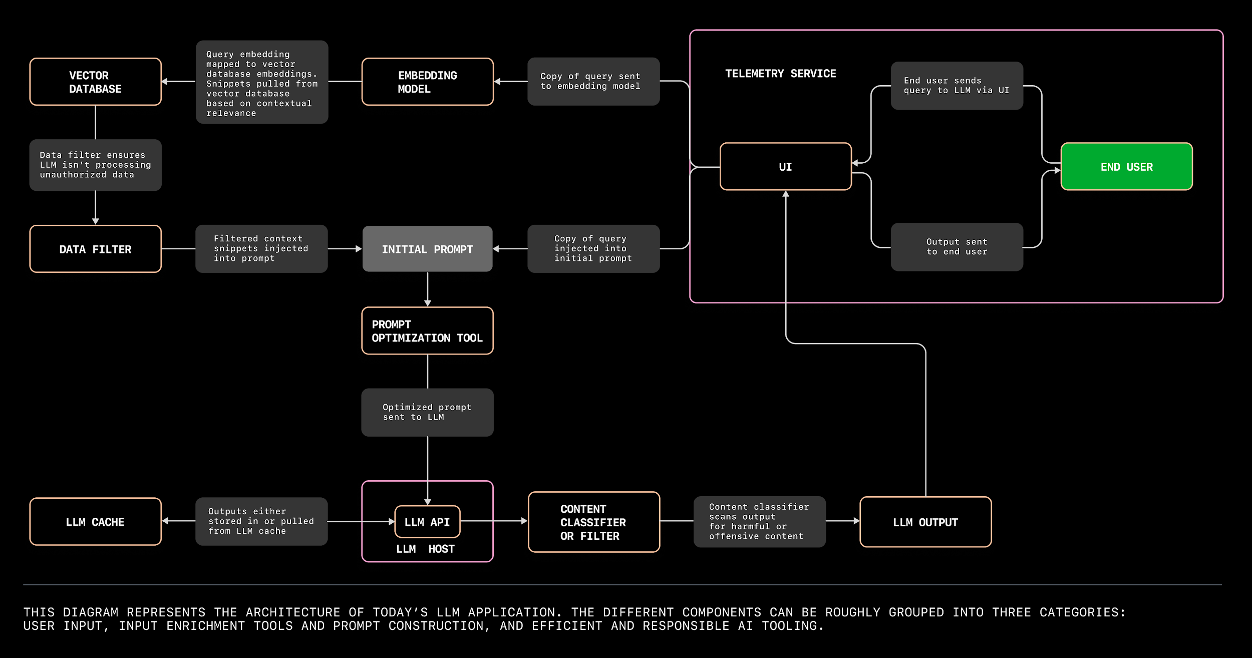
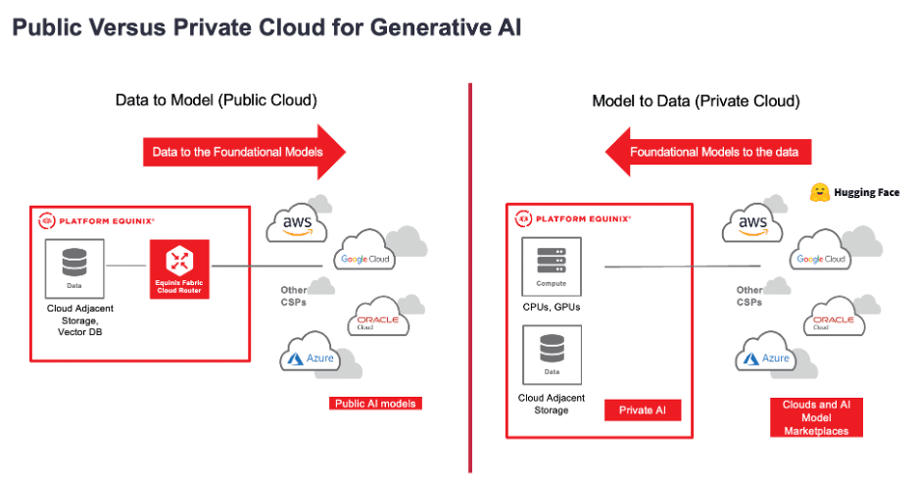
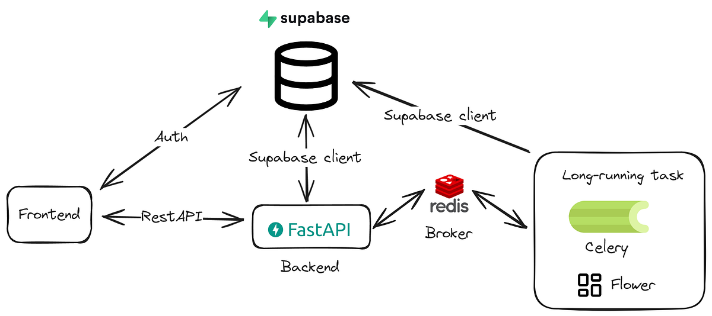

1️⃣ What Does “Using AI via API” Mean?
API-based AI = Your application sends a request (prompt) to an AI service and gets a response (text, JSON, etc.).
Frontend / App
↓ API
Backend (Python / FastAPI)
↓ API
LLM

This is how:
- Websites
- Mobile apps
- Internal tools
- Government portals
use AI.

☁️ PART A: Cloud AI using API

Typical Cloud Providers
- Hugging Face (Inference API)
- OpenAI (GPT)
- Cloud LLM services

☁️ Cloud AI Architecture (Explain in 1 slide)
User App
↓
Backend (FastAPI)
↓ Internet
↓
Cloud LLM API

☁️ Example 1: Hugging Face Inference API (Python)

Step 1: Get API Token
From Hugging Face → Settings → Access Tokens

Step 2: Python Code (Cloud API)
import requests

API_URL = "https://api-inference.huggingface.co/models/mistralai/Mistral-7B-Instruct-v0.2"
HEADERS = {"Authorization": "Bearer YOUR_HF_API_KEY"}

def cloud_llm(prompt):
response = requests.post(
API_URL,
headers=HEADERS,
json={"inputs": prompt}
)
return response.json()[0]["generated_text"]

print(cloud_llm("Explain AI in simple words"))

☁️ Real Business Use Cases (Cloud API)
Use Case | Why Cloud
Marketing content | Fast
Chatbots | Scalable
Prototyping | No infra
Demo / POC | Easy

⚠️ Cloud API Limitations (Be Honest)
❌ Data leaves your system
❌ Ongoing API cost
❌ Vendor lock-in
❌ Compliance issues for govt/banks

🏠 PART B: Private AI using API (Ollama)

Private AI API = You host the model
Powered by:

🟢 Ollama

🏠 Private AI Architecture
User App
↓
Backend (FastAPI)
↓
Ollama API (Local / Private VM)
↓
LLM (Mistral / LLaMA / Qwen)

✔ No internet
✔ Full data control
✔ Production-ready

🏠 Example 2: Ollama API (Python)

Ollama runs at:
http://localhost:11434

Python Code (Private AI API)
import requests

OLLAMA_URL = "http://localhost:11434/api/generate"

def private_llm(prompt, model="mistral"):
response = requests.post(
OLLAMA_URL,
json={
"model": model,
"prompt": prompt,
"stream": False
}
)
return response.json()["response"]

print(private_llm("Summarize this resume: SQL, Python, Power BI"))

🏠 Real Business Use Cases (Private API)
Use Case | Why Private
HR resume screening | Sensitive data
Legal documents | Compliance
Government systems | Security
Healthcare | Privacy
Internal AI assistants | Offline

⚖️ Cloud API vs Private API (Side-by-Side)
Feature | Cloud API | Private API
Setup | Easy | Medium
Data privacy | ❌ | ✅
Cost | Pay per request | Infra only
Offline | ❌ | ✅
Compliance | Limited | High
Customization | Limited | Full

🧠 Hybrid API (BEST PRACTICE – REAL WORLD)
if data_is_sensitive:
use_private_ai()
else:
use_cloud_ai()

Used by:
- Banks
- Governments
- Large enterprises

🧪 Hybrid Python Example
def smart_llm(prompt, sensitive=False):
if sensitive:
return private_llm(prompt)
else:
return cloud_llm(prompt)

🚀 Production-Ready API (FastAPI Skeleton)
from fastapi import FastAPI
import requests

app = FastAPI()

@app.post("/ai")
def ai_endpoint(prompt: str, sensitive: bool = False):
if sensitive:
return {"response": private_llm(prompt)}
else:
return {"response": cloud_llm(prompt)}

✔ Ready for web apps
✔ Ready for mobile apps
✔ Ready for government portals

🎤 20-Second Interview Answer (Memorize)
“Cloud AI APIs are best for speed and scale, but private AI APIs are required when data privacy and compliance matter.
Most enterprises use a hybrid API strategy combining both.”

🎓 Teaching Flow (Highly Effective)
1️⃣ Explain API concept
2️⃣ Show Cloud API call
3️⃣ Show Private API call
4️⃣ Compare latency & privacy
5️⃣ Introduce hybrid logic

🔥 What Can I Add Next?
- 🔐 API authentication & rate limiting
- 📄 RAG via API (PDF → Answer)
- 🐳 Dockerized API server
- ☁️ GCP/AWS deployment
- 🧪 Load testing AI APIs

Excellent choice 👍
Below is a SINGLE, CLEAN, DEMO-READY Jupyter / Colab NOTEBOOK that calls ALL FREE / FREE-TIER LLM APIs from one place.
You can:
- Run this in Google Colab
- Download as .ipynb
- Use it for live teaching, interviews, workshops
- Switch models with one dropdown
- Explain cloud vs open vs private AI clearly

📘 Single Notebook – ALL Free LLM APIs (Demo Ready)
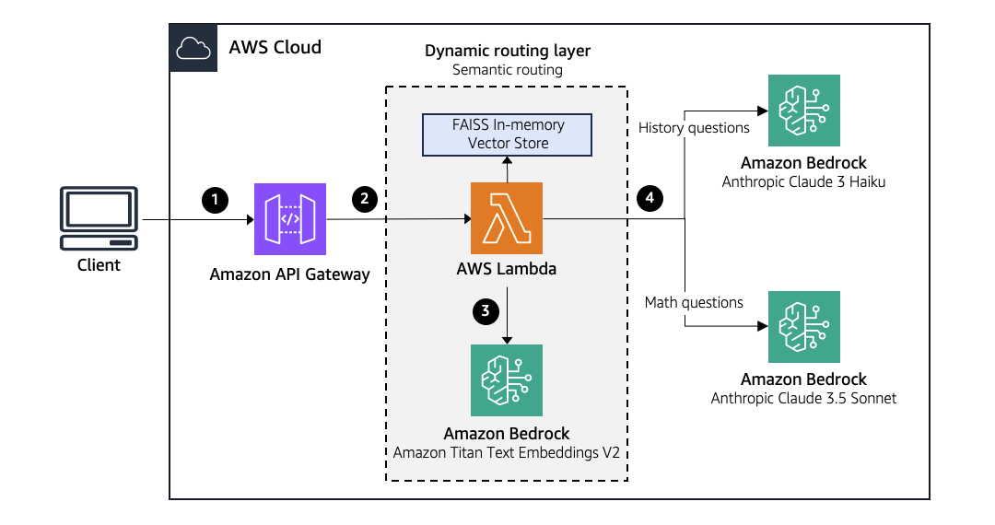
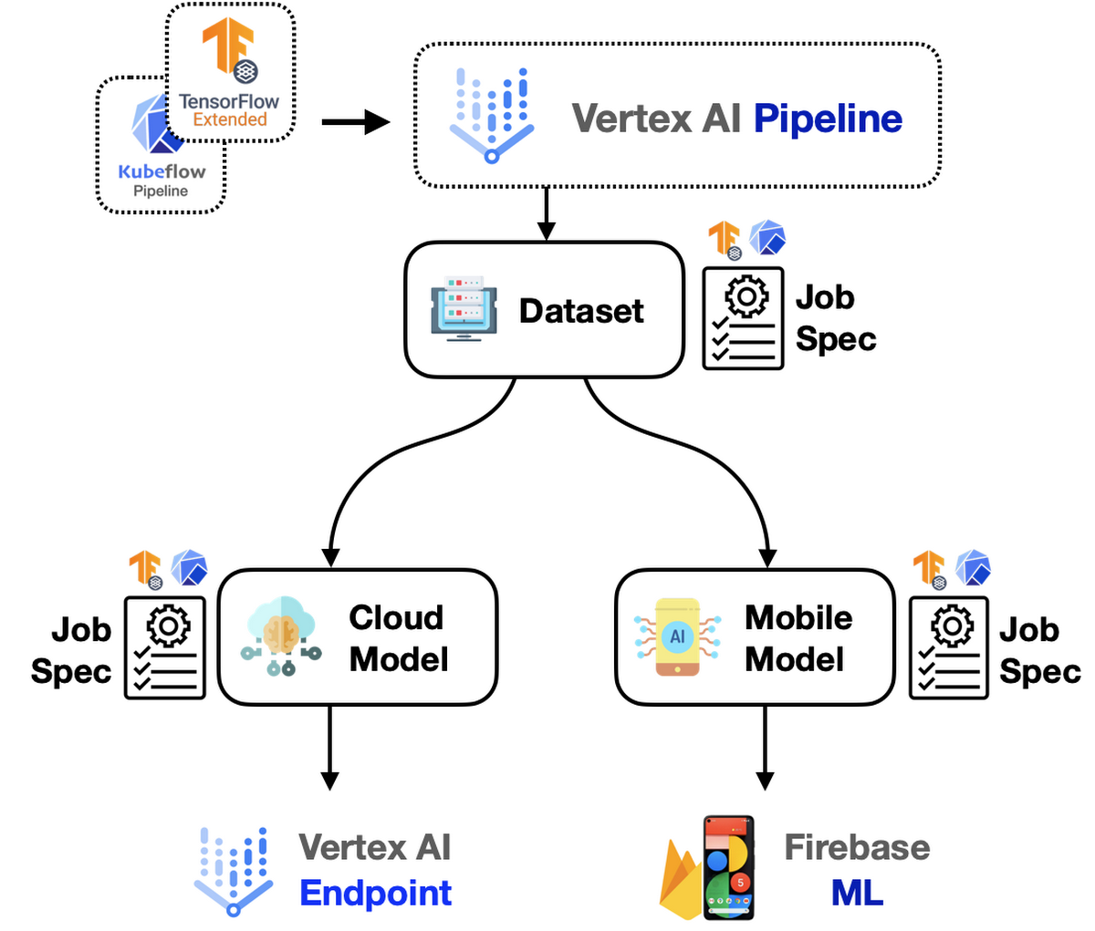
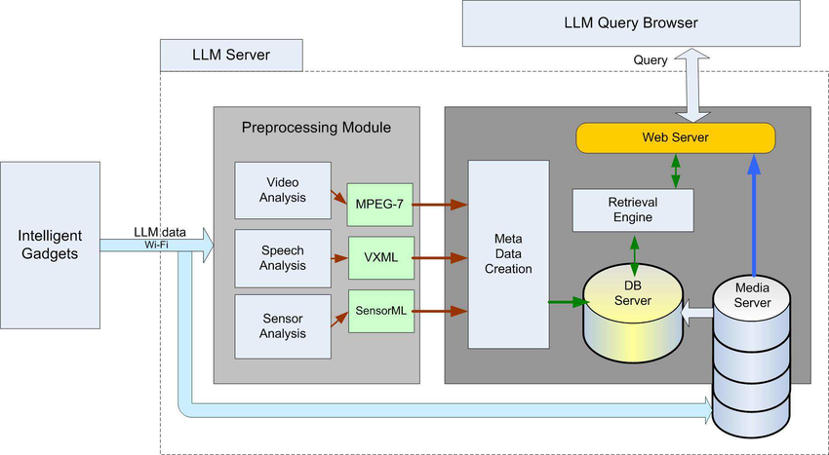

🧠 APIs Covered (FREE / FREE-TIER)
- 🟢 Hugging Face (Open-source, free tier)
- 🟢 Google Gemini (Free tier)
- 🟢 OpenRouter (Free quota)
- ⚠️ OpenAI (Free credits)
- ⚠️ Anthropic (Trial credits)

🔹 CELL 1: Install Libraries (Colab)
!pip install -q requests google-generativeai openai anthropic

🔹 CELL 2: Add Your API Keys (ONE PLACE)
HF_TOKEN = "YOUR_HF_TOKEN"
GEMINI_API_KEY = "YOUR_GEMINI_KEY"
OPENROUTER_API_KEY = "YOUR_OPENROUTER_KEY"
OPENAI_API_KEY = "YOUR_OPENAI_KEY" # optional
ANTHROPIC_API_KEY = "YOUR_ANTHROPIC_KEY" # optional

👉 For demos, HF + Gemini + OpenRouter is enough (100% free)

🔹 CELL 3: Hugging Face (FREE – Open-Source Models)
import requests

def hf_llm(prompt, model="mistralai/Mistral-7B-Instruct-v0.2"):
response = requests.post(
f"https://api-inference.huggingface.co/models/{model}",
headers={"Authorization": f"Bearer {HF_TOKEN}"},
json={"inputs": prompt}
)
return response.json()[0]["generated_text"]

🔹 CELL 4: Google Gemini (FREE Tier)
import google.generativeai as genai

genai.configure(api_key=GEMINI_API_KEY)

def gemini_llm(prompt):
model = genai.GenerativeModel("gemini-1.5-flash")
return model.generate_content(prompt).text

🔹 CELL 5: OpenRouter (FREE Multi-Model Gateway)
def openrouter_llm(prompt, model="mistralai/mistral-7b-instruct"):
response = requests.post(
"https://openrouter.ai/api/v1/chat/completions",
headers={
"Authorization": f"Bearer {OPENROUTER_API_KEY}",
"Content-Type": "application/json"
},
json={
"model": model,
"messages": [{"role": "user", "content": prompt}]
}
)
return response.json()["choices"][0]["message"]["content"]

🔹 CELL 6: ChatGPT (Optional – Free Credits)
from openai import OpenAI
client = OpenAI(api_key=OPENAI_API_KEY)

def chatgpt_llm(prompt):
response = client.chat.completions.create(
model="gpt-4o-mini",
messages=[{"role": "user", "content": prompt}]
)
return response.choices[0].message.content

🔹 CELL 7: Claude (Optional – Trial)
import anthropic
client_claude = anthropic.Anthropic(api_key=ANTHROPIC_API_KEY)

def claude_llm(prompt):
message = client_claude.messages.create(
model="claude-3-haiku-20240307",
max_tokens=300,
messages=[{"role": "user", "content": prompt}]
)
return message.content[0].text

🔹 CELL 8: Universal Router (⭐ MOST IMPORTANT)
def run_llm(provider, prompt):
if provider == "HuggingFace":
return hf_llm(prompt)
elif provider == "Gemini":
return gemini_llm(prompt)
elif provider == "OpenRouter":
return openrouter_llm(prompt)
elif provider == "ChatGPT":
return chatgpt_llm(prompt)
elif provider == "Claude":
return claude_llm(prompt)
else:
return "Invalid provider"

🔹 CELL 9: Real-World Demo Prompt
PROMPT = """
You are an HR assistant.
Analyze this resume and tell if the candidate is suitable for Data Analyst role.
Skills: SQL, Python, Power BI, Excel
"""

🔹 CELL 10: Run ALL Models (Side-by-Side)
providers = ["HuggingFace", "Gemini", "OpenRouter"]

for p in providers:
print(f"\n--- {p} OUTPUT ---")
print(run_llm(p, PROMPT))

🎤 How to Explain This in Class / Interview
“This single notebook compares multiple AI providers using their APIs.
Open-source models come from Hugging Face, Big-Tech models from Google Gemini, and multi-model access via OpenRouter.
This is exactly how companies evaluate AI vendors.”

🏆 Best FREE Combo (Recommended)
Purpose | Provider
Open-source demo | Hugging Face
Big-Tech AI | Gemini
Model comparison | OpenRouter
Private AI | Ollama (local)

📦 Download Notebook
In Colab:
File → Download → .ipynb

🚀 Want Next?
I can now:
- 🔄 Add Gradio UI to switch providers
- 📊 Add side-by-side comparison table
- 📄 Add RAG demo (PDF → answer)
- 🏠 Add Ollama private AI in same notebook
- 📘 Convert this into PDF teaching notes
Just tell me next step 👨‍🏫🔥

